**01_****pattern** : Description-To read n and generate a below pattern

1

1 2

1 2 3

1 2 3 4

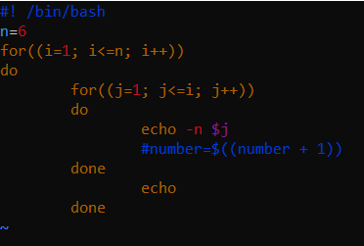

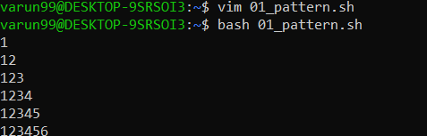

**02_****pattern** : Description-To read n and generate a below pattern

1

2 3

4 5 6

7 8 9 10

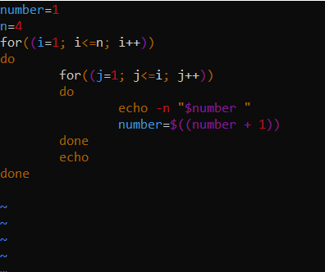

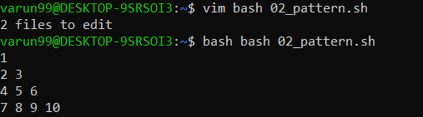

**03_real_****add** : Description-Script for addition of two real numbers

Input-bash 03_real_add.sh

Enter the numbers to addition: 4.28 1.21

Output- The sum of 4.28 and 1.21 is 5.49

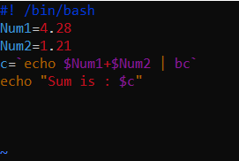

**05_****Largest :** Description- Script to compare larger integer values from a 'n' number of arguments using command line arguments

Input- bash 05_largest.sh 1 3 8 6 5 7 9 2

Output- The largest value is 9

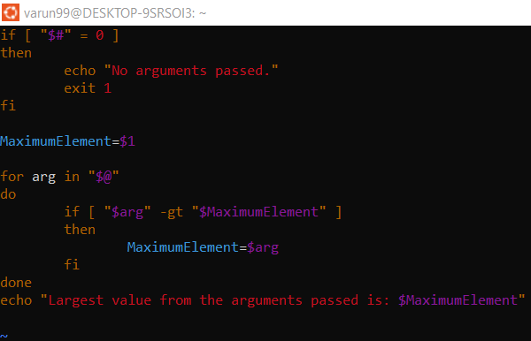



**06_****Reverse** : Description- Script to print a given number in reverse order.

Input- bash 06_reverse.sh 639872

Output- The reversed number of entered number is 278936

